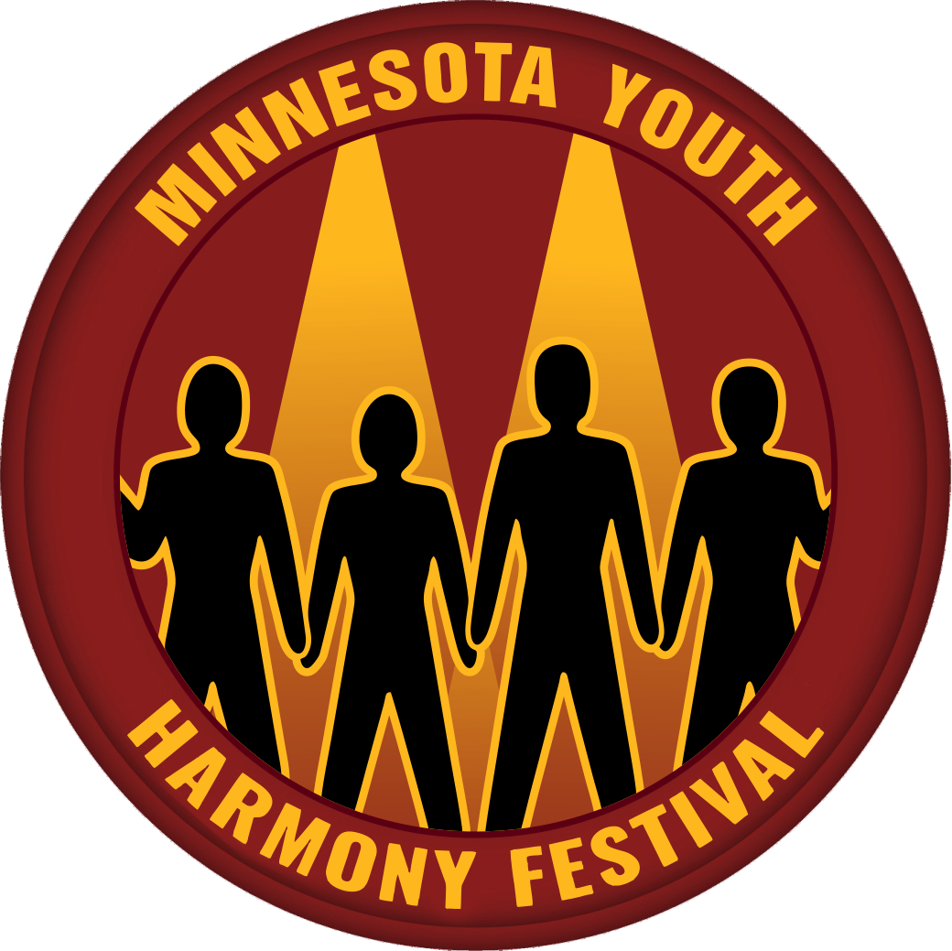

Quartet Registration Form

Wisconsin Youth Harmony Festival
Deadline for Registrations: May 18th

Music Educator Contact ________________________________________________________________________

Email _____________________________________________________________________

School ____________________________________________ City ________________________________________

Quartet Name (Required) _________________________________________________________________

Tenor: | Lead:
Bari: | Bass:

Would you like to receive an evaluation from the judges? YES [ ] NO [ ]
Please return this form via email to: bschmitt640@gmail.com

