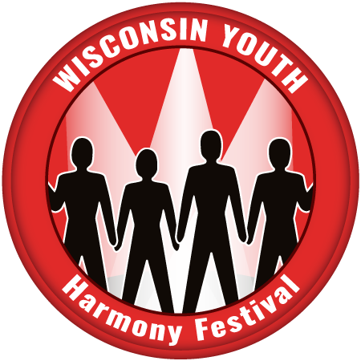

Parent Permission Form

Wisconsin Youth Harmony Festival
Deadline for Registrations: May 18th

First name ________________________ Last name _______________________________

Quartet Name (If participating) _________________________________________________

Student Voice Part: Tenor [ ] Lead [ ] Baritone [ ] Bass [ ]

Home address _________________________________________________________

City/St/Zip ____________________________________________________________

Home phone # ______________________ Cell #_____________________________

Student/Family Email ______________________________________________________

School _______________________________________Year/Grade ______________

Parent/Guardian name(s) ________________________________________________

Parent/Guardian Email address ___________________________________________

Parent/Guardian Emergency Phone # ______________________________________

Student be traveling with: Parent [ ] Chaperone [ ]

With whom will student go home? ___________________________ Phone #_____________

Any special dietary needs for lunch? ________________________________________

As Parent [ ] Guardian [ ] I give my permission for the above-named student, to attend this event:
Signed _________________________________________________________

Best to return via email to: bschmitt640@gmail.com

You may also mail it to: Bob Brey
1411 S 31st St.
Manitowoc, WI 54220

